Database Setup (MySQL)

Create Database
CREATE DATABASE hr_database_Management_and_Candidate_Tracking_System;
USE hr_database_Management_and_Candidate_Tracking_System;

Create Table
CREATE TABLE candidates (
candidate_id VARCHAR(20) PRIMARY KEY,
age INT,
gender VARCHAR(10),
degree VARCHAR(50),
specialization VARCHAR(100),
university_tier VARCHAR(20),
cgpa DECIMAL(3,2),
years_experience INT,
internships_count INT,
projects_count INT,
certifications_count INT,

python_skill INT,
sql_skill INT,
machine_learning_skill INT,
deep_learning_skill INT,
communication_skill INT,
leadership_skill INT,

github_projects INT,
kaggle_activity_score DECIMAL(4,1),
hackathons_participated INT,
expected_salary_lpa DECIMAL(5,2),
location VARCHAR(100),
employment_gap_months INT,
selected VARCHAR(5)
);

Inserting data
INSERT INTO candidates (
candidate_id, age, gender, degree, specialization, university_tier,
cgpa, years_experience, internships_count, projects_count,
certifications_count, python_skill, sql_skill,
machine_learning_skill, deep_learning_skill,
communication_skill, leadership_skill,
github_projects, kaggle_activity_score,
hackathons_participated, expected_salary_lpa,
location, employment_gap_months, selected
)
VALUES
('CAND-000001',24,'Female','B.Tech','Information Technology','Tier 3',8.75,6,1,2,2,6,7,8,7,6,4,3,6.1,2,16.5,'Kolkata',0,'No');

Like:

#output
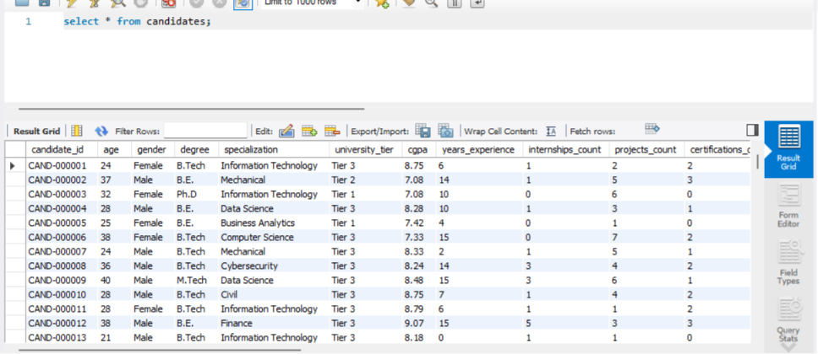

MySQL Queries

Total Candidates
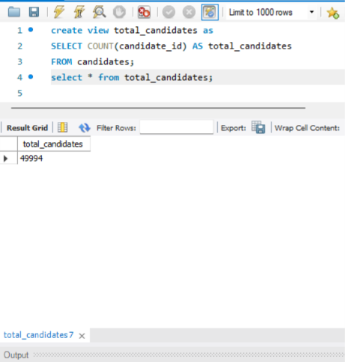

Selected Candidates
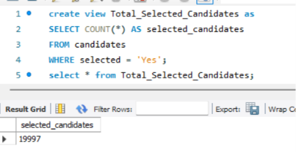

Rejected Candidates
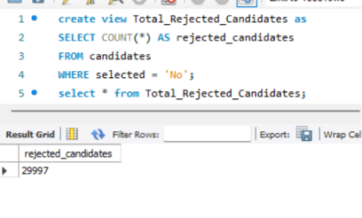

Selection Rate
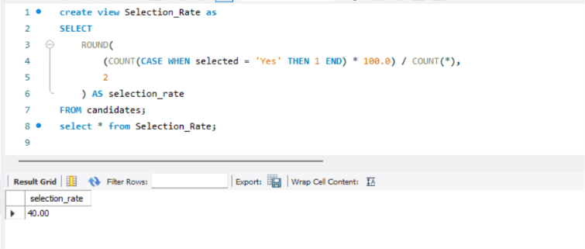

Selected Candidates by Gender
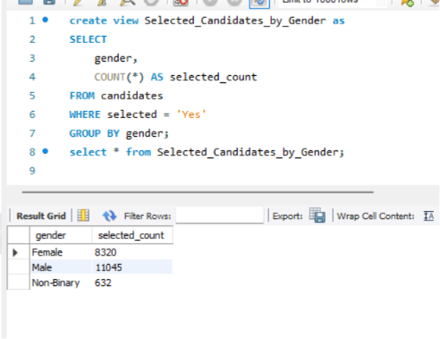

Selected Candidates by Degree
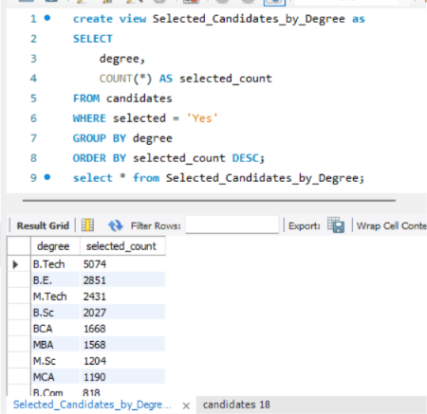

Selected Candidates by Experience
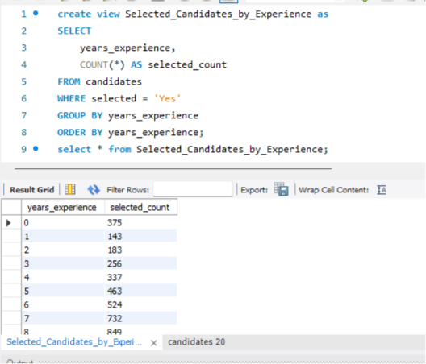

Average Skills of Selected Candidates
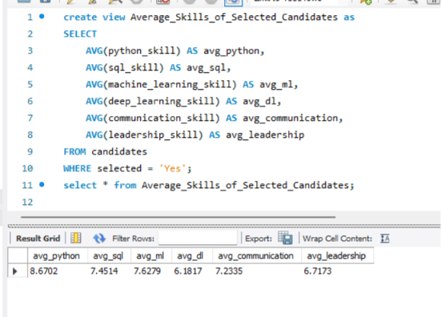

Top 10 Selected Candidates (Highest SQL Skill)
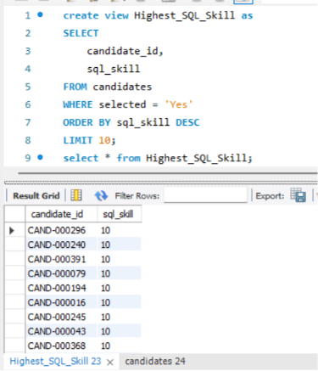

Average Experience
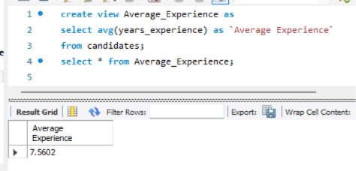

Average CGPA
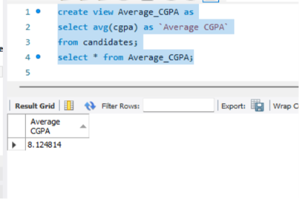

Average Salary
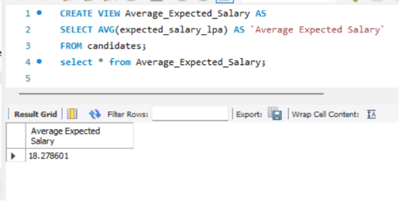

Average SQL Skill
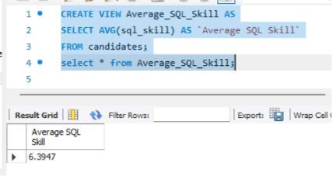

Average Python Skill
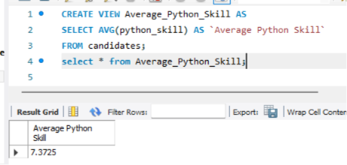

JOINS
Joins in SQL are used to combine rows from two or more tables based on a related column between them.

INNER JOIN
Ex:
Match onleft.customer_id = right.customer_id
Left table
customer_id | customer
1 | Ava
2 | Bo
4 | Dee
Right table
customer_id | level
1 | Gold
3 | Silver
4 | Bronze
↓
INNER JOIN · Result
customer_id | customer | level
1 | Ava | Gold
4 | Dee | Bronze
# Only matching keys 1 and 4 remain

LEFT JOIN
EX:
Match onleft.customer_id = right.customer_id
Left table
customer_id | customer
1 | Ava
2 | Bo
4 | Dee
Right table
customer_id | level
1 | Gold
3 | Silver
4 | Bronze
↓
LEFT JOIN · Result
customer_id | customer | level
1 | Ava | Gold
2 | Bo | NULL
4 | Dee | Bronze

# Keep every left row; missing levels become NULL

RIGHT JOIN
EX:
Match onleft.customer_id = right.customer_id
Left table
customer_id | customer
1 | Ava
2 | Bo
4 | Dee
Right table
customer_id | level
1 | Gold
3 | Silver
4 | Bronze
↓
RIGHT JOIN · Result
customer_id | customer | level
1 | Ava | Gold
3 | NULL | Silver
4 | Dee | Bronze

# Keep every right row; missing customers become NULL

FULL OUTER JOIN
Match onleft.customer_id = right.customer_id
Left table
customer_id | customer
1 | Ava
2 | Bo
4 | Dee
Right table
customer_id | level
1 | Gold
3 | Silver
4 | Bronze
↓
FULL OUTER JOIN · Result
customer_id | customer | level
1 | Ava | Gold
2 | Bo | NULL
3 | NULL | Silver
4 | Dee | Bronze
# Keep every row; missing customers or levels become NULL

